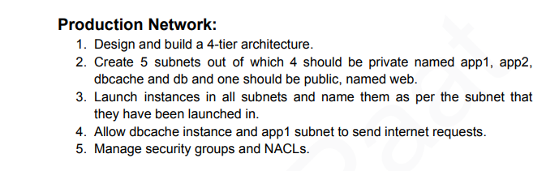
VPC CIDR: 10.0.0.0/16
App1 Private Subnet: 10.0.1.0/24
App2 Private Subnet: 10.0.2.0/24
dbcache Private Subnet: 10.0.3.0/24
db Private Subnet: 10.0.4.0/24
WebServer Public Subnet: 10.0.5.0/24
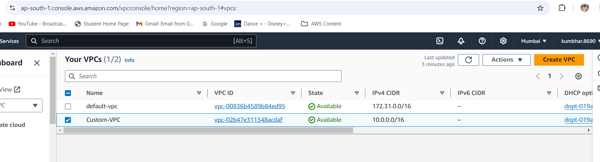
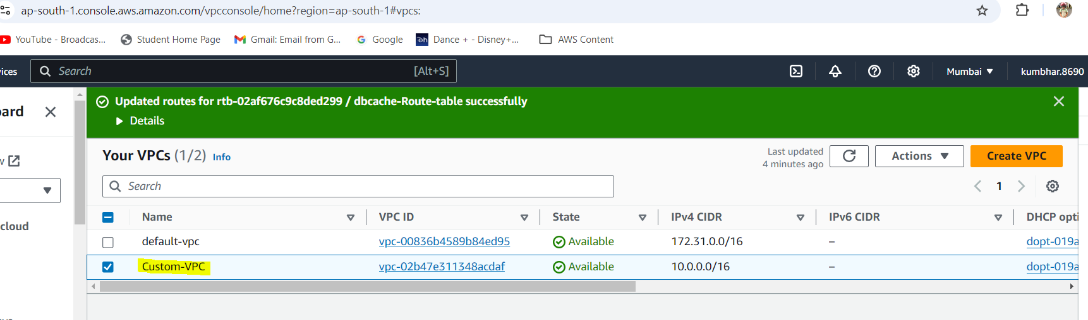
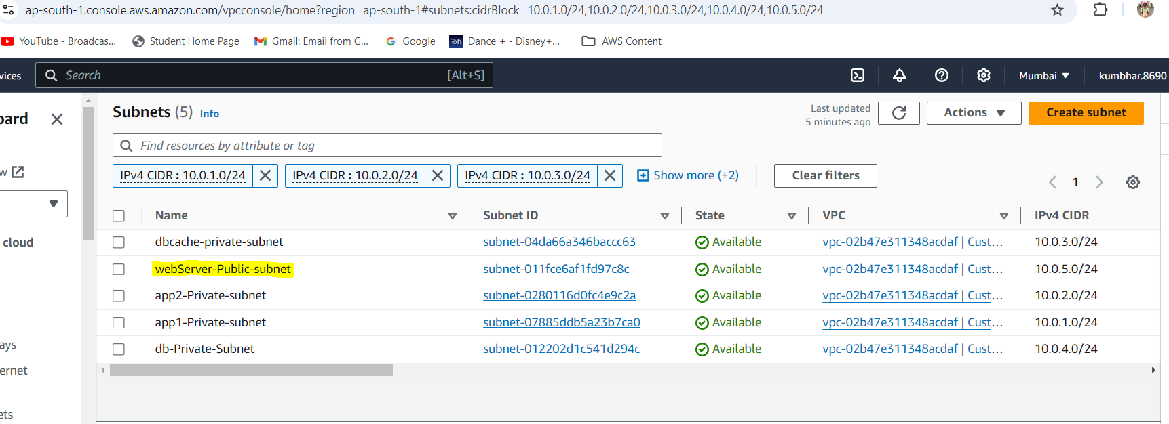
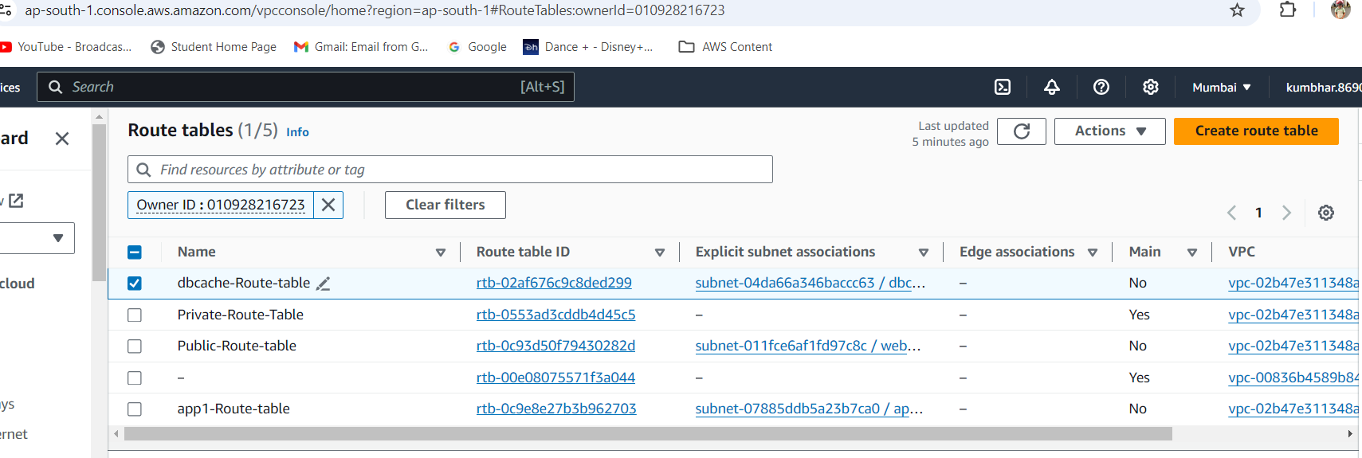
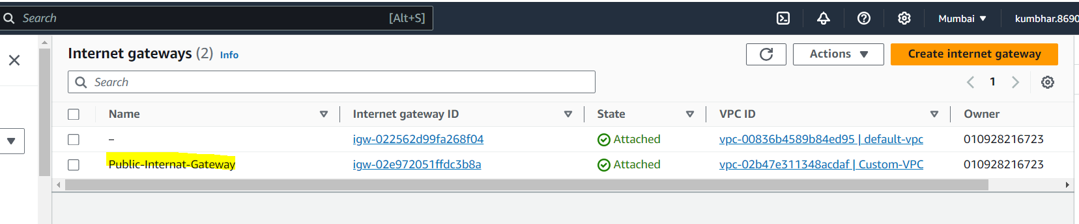
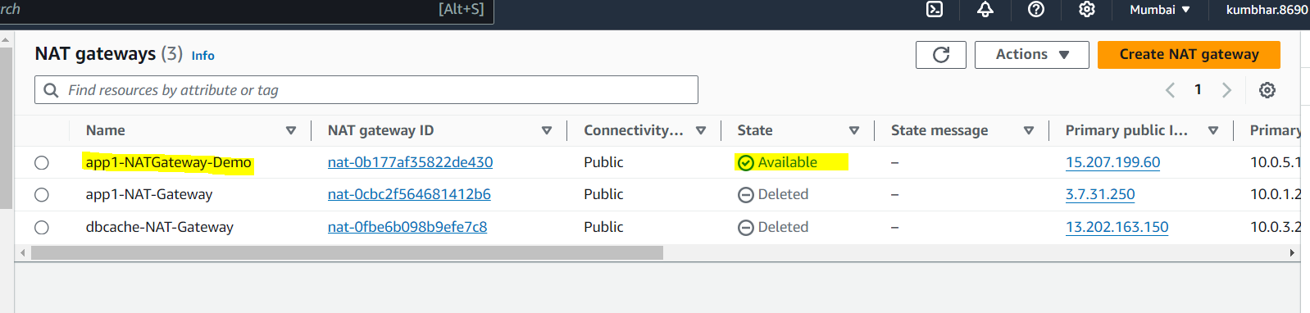
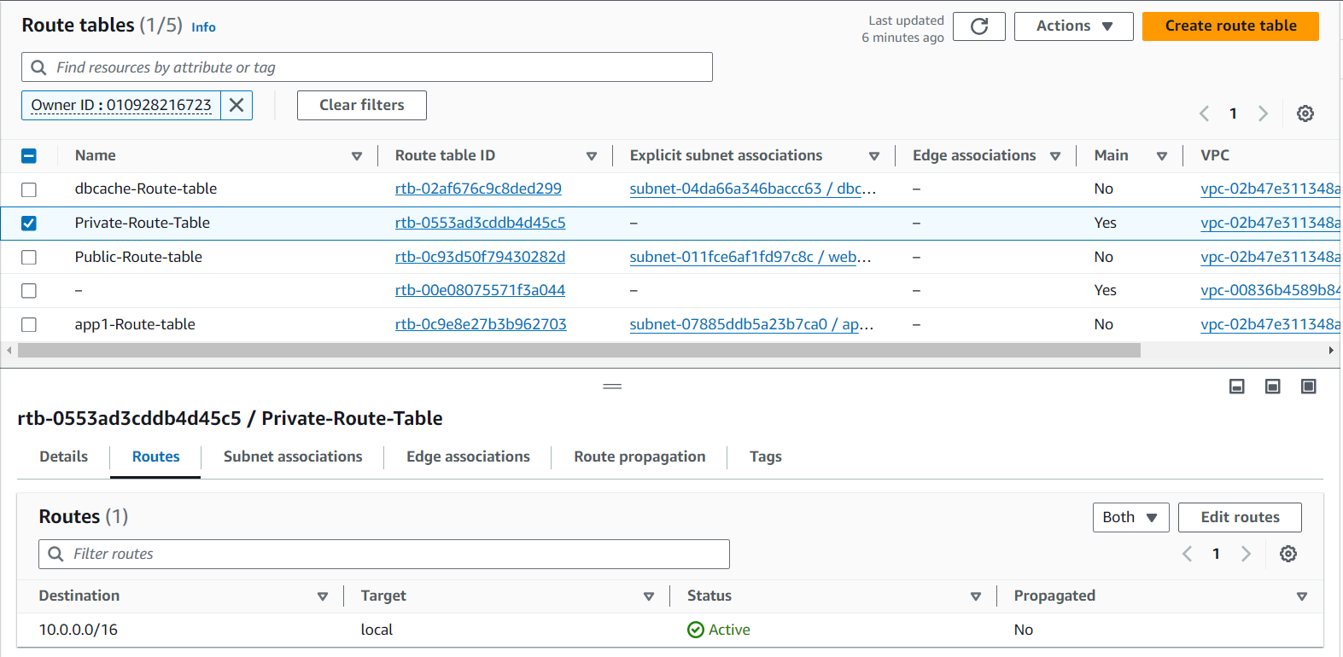
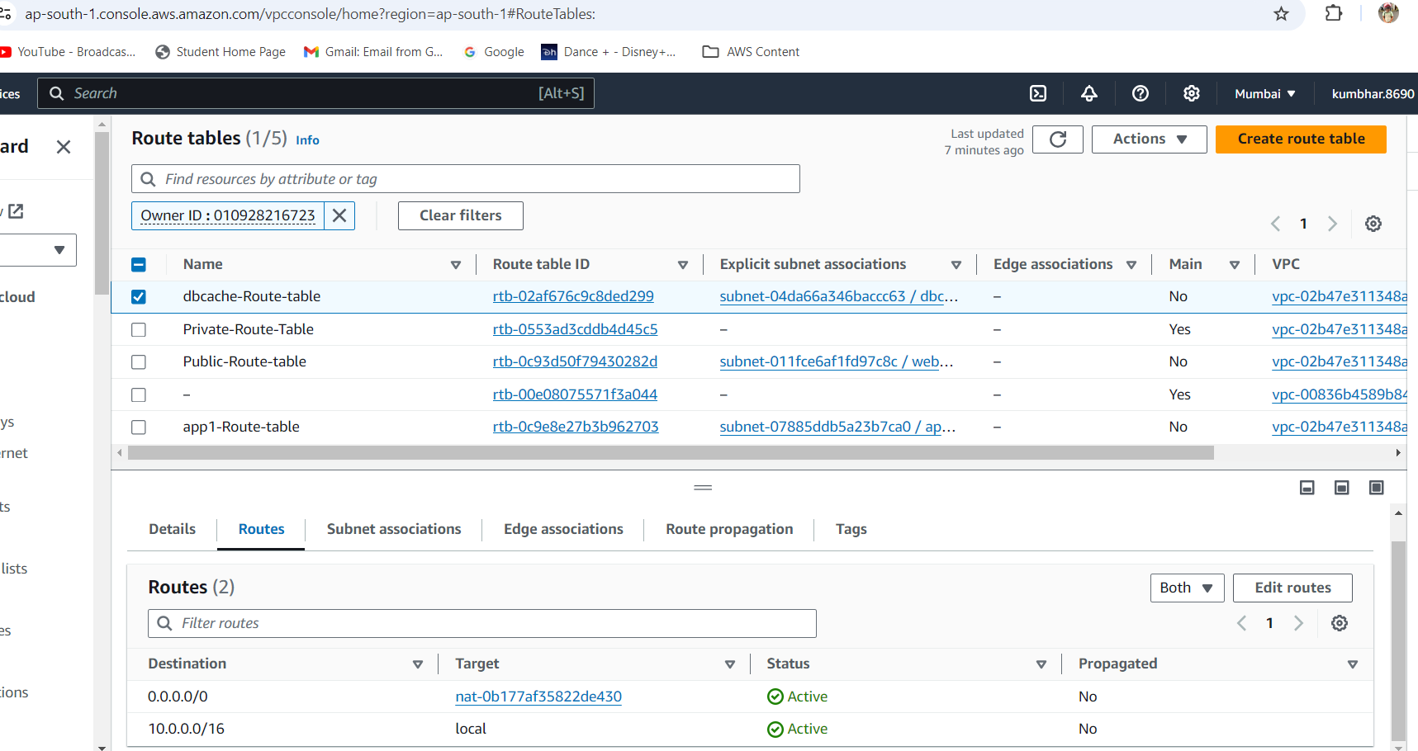
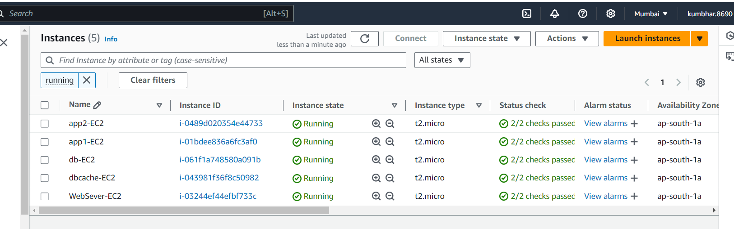

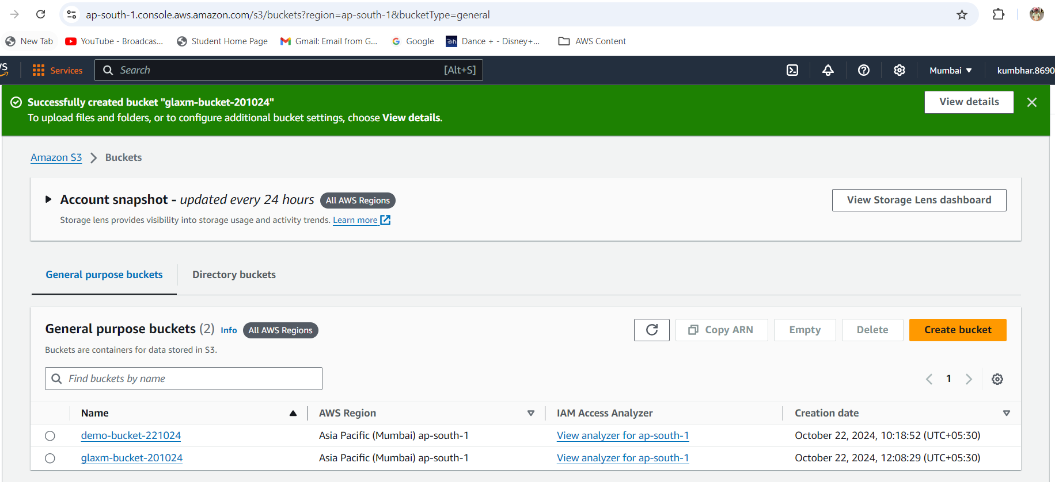
Connect to app1 Private Instance from Web Server Public Instance
App1 SG Setting
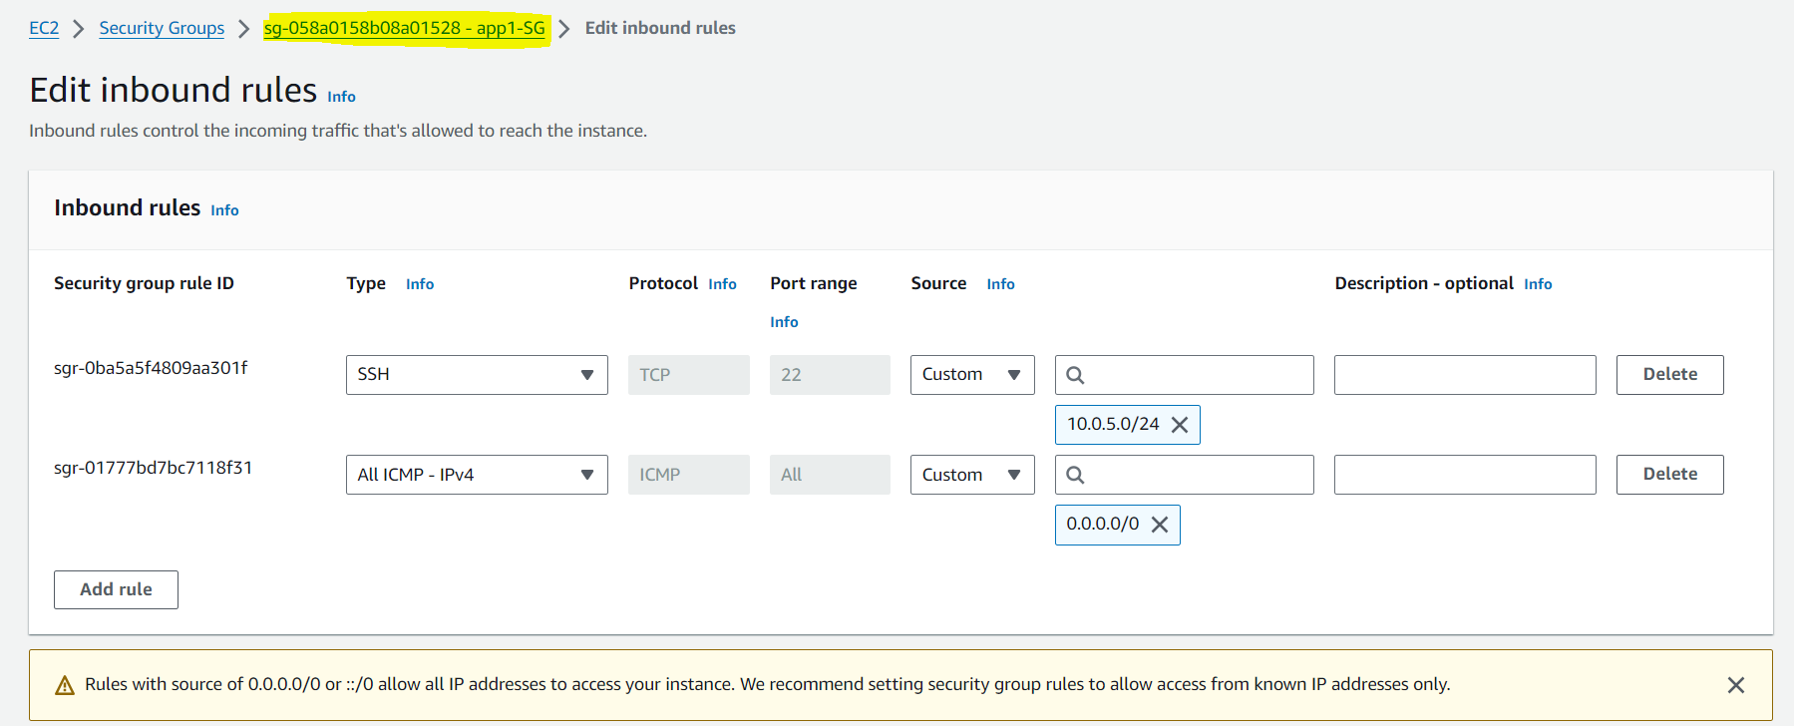
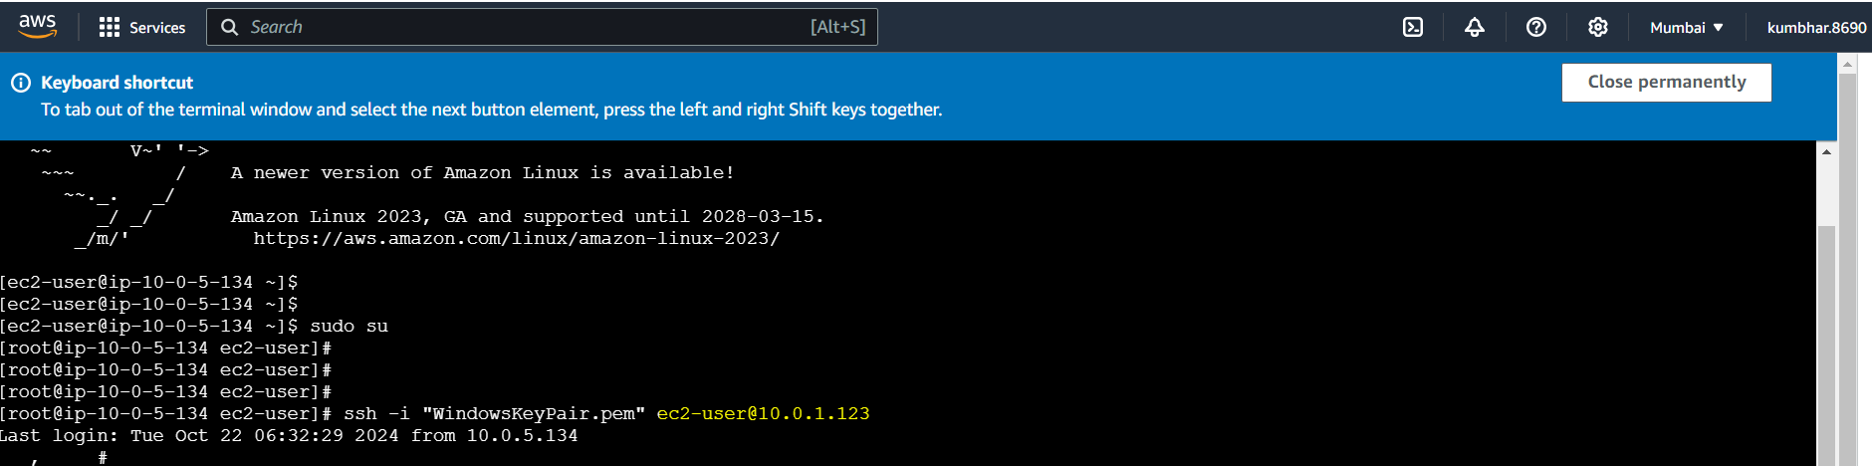
Internet Access From App1 Private Instance via NAT Gateway
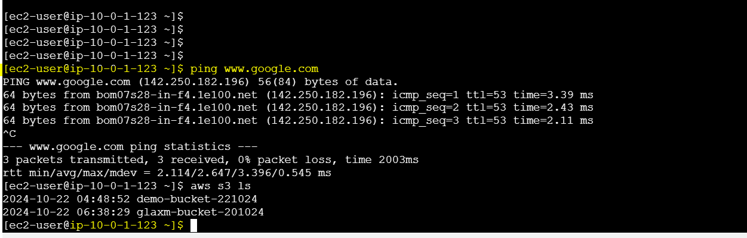
Connect to dbcache Private Instance from Web Server Public Instance
dbcache SG Setting
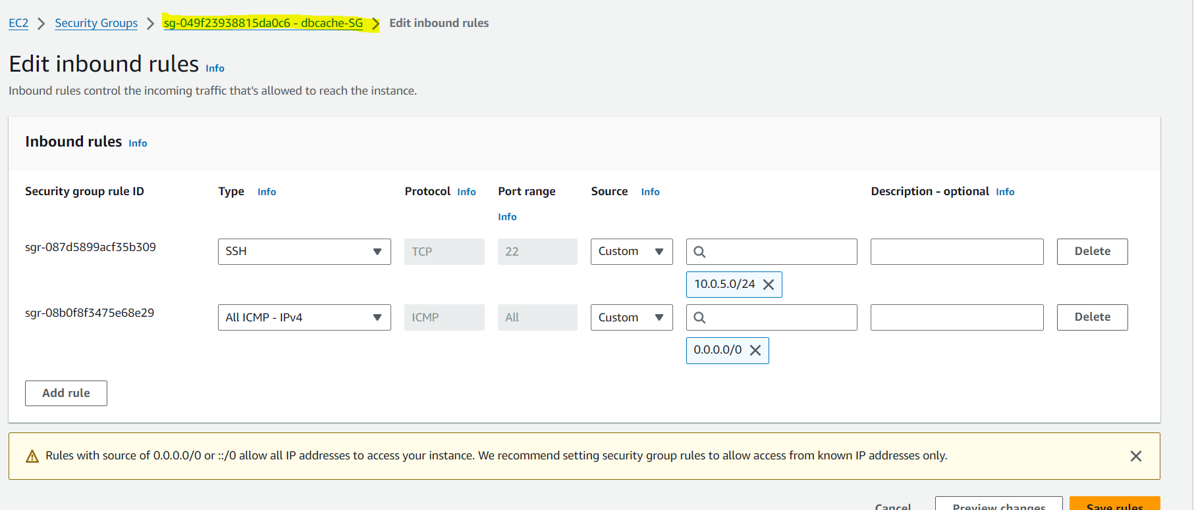
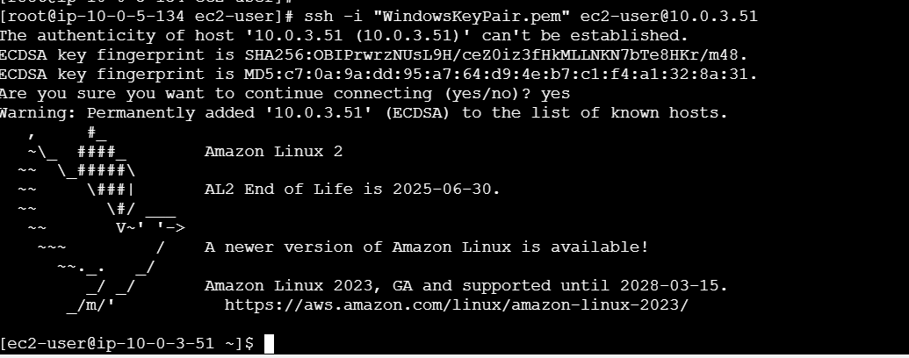

Access to the internet via NAT Gateway
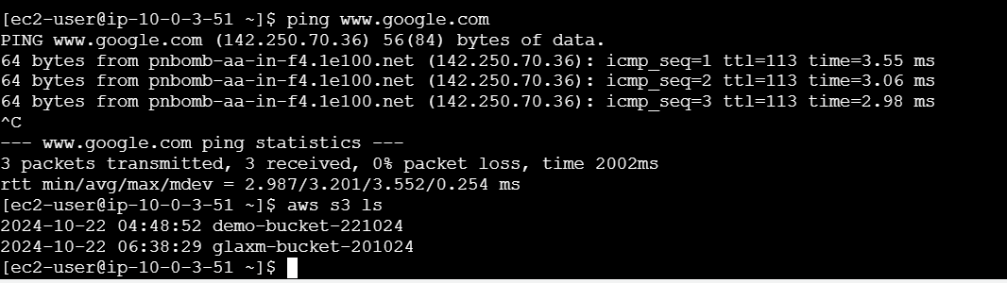

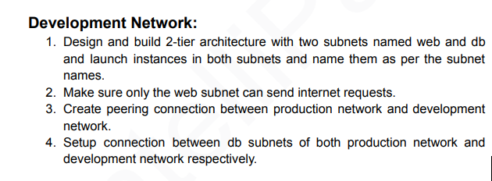
Prod VPC CIDR: 10.0.0.0/24
Dev VPC CIDR: 10.0.1.0/24
Prod Public Subnet CIDR: 10.0.0.0/28
Prod Private Subnet CIDR: 10.0.0.128/28
Dev Public Subnet CIDR: 10.0.1.0/28
Dev Private Subnet CIDR: 10.0.1.128/28
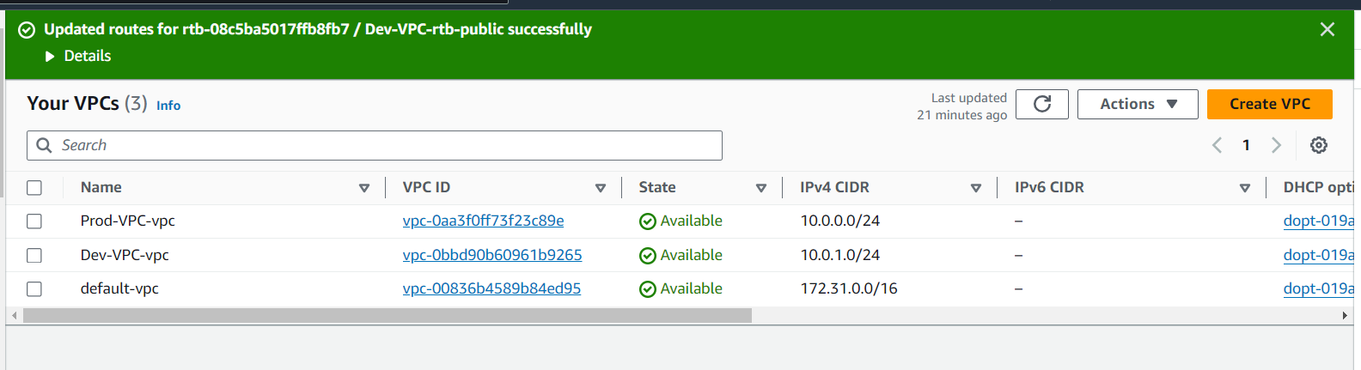
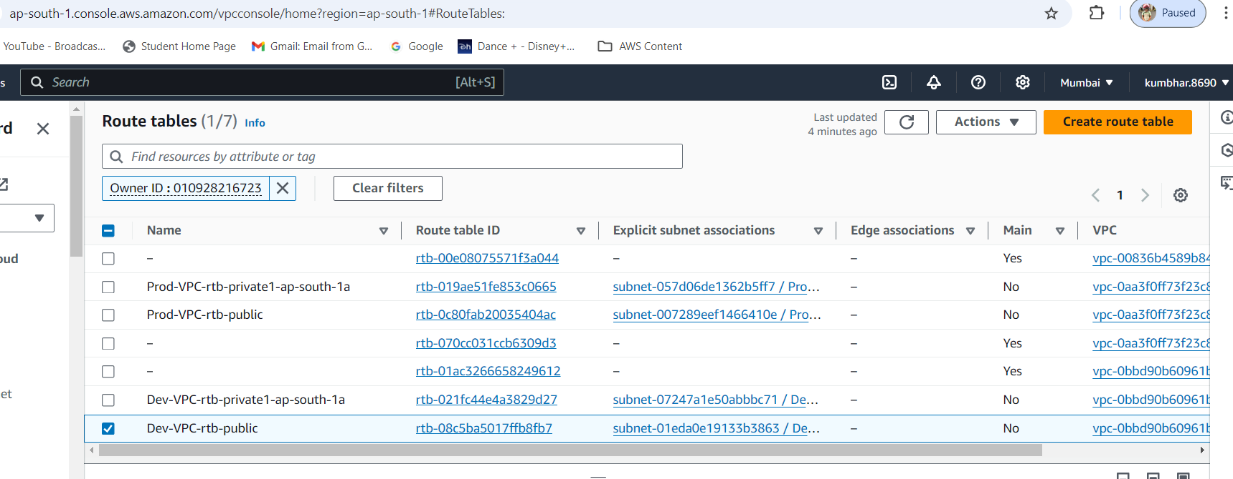
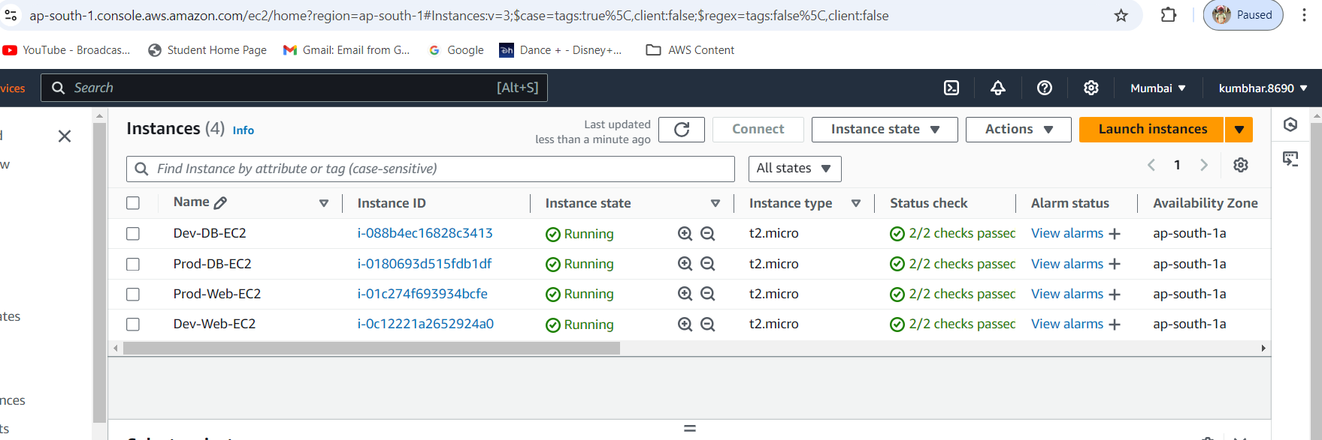

2. Make sure only the web subnet can send internet requests.
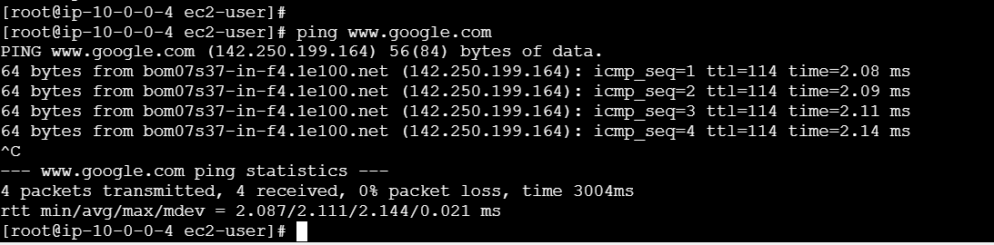

3. Create peering connection between production network and development network
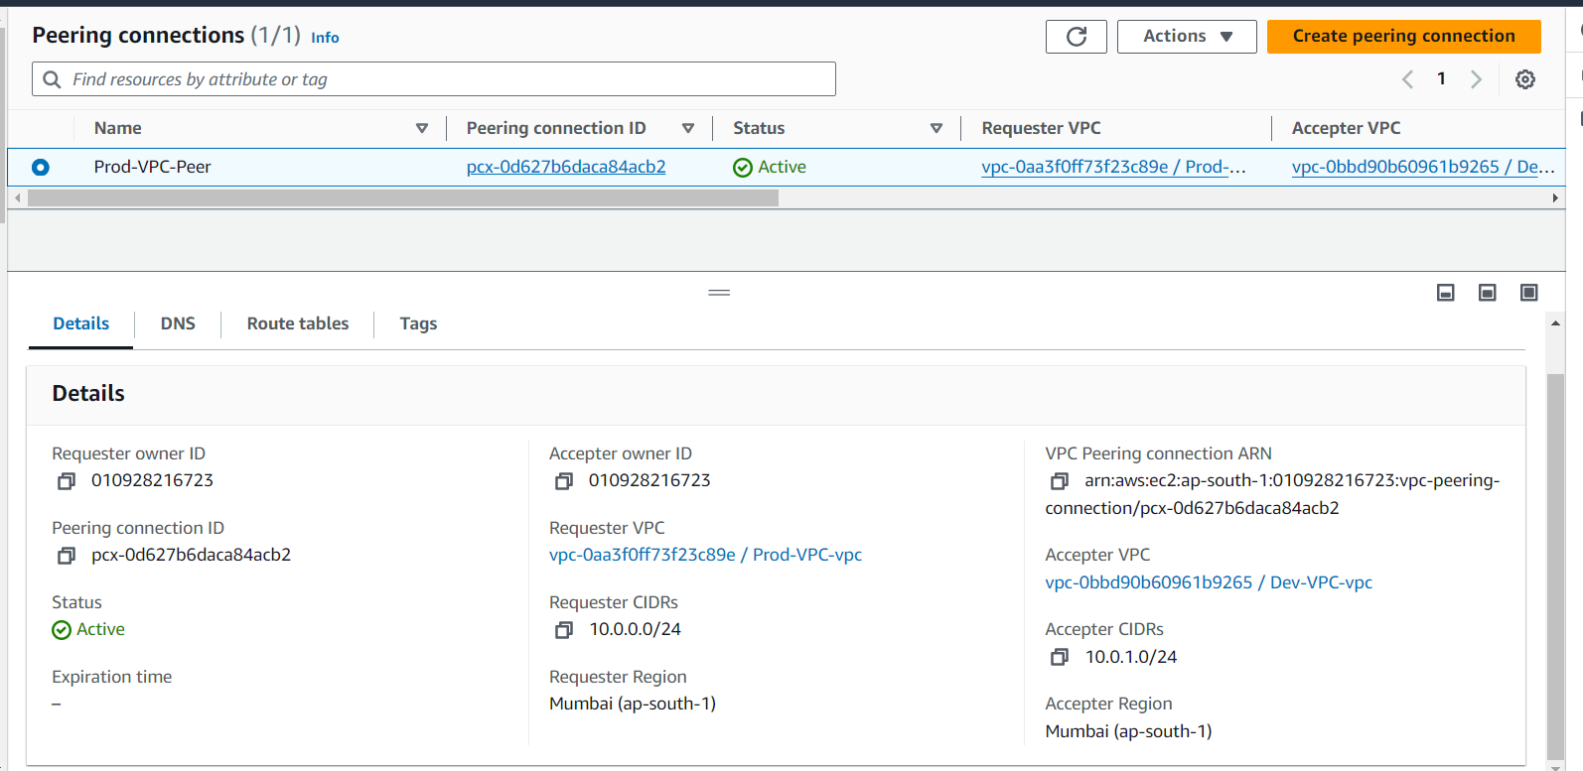
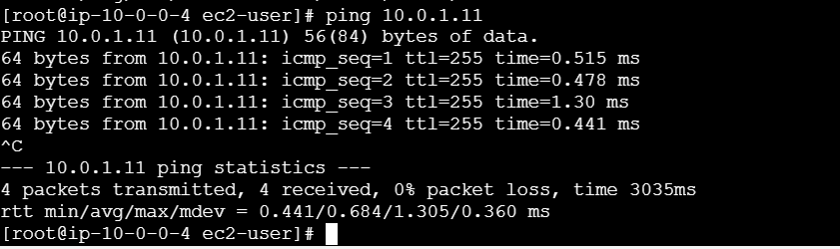
4. Setup connection between db subnets of both production network and development network respectively.
Connection to Prod DB from Prod Web Server
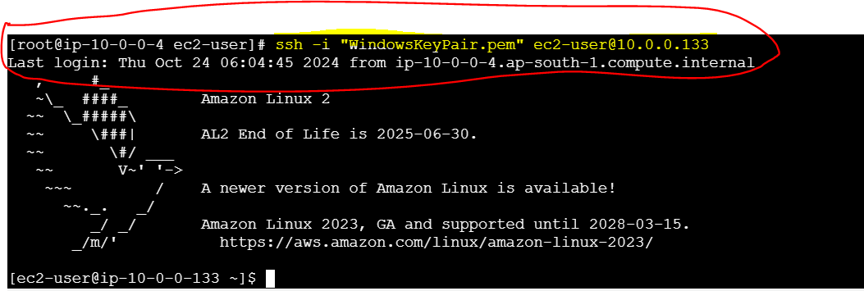

Connection between Prod DB and Dev DB
